Hi Everyone
Our current situation of being in Lockdown looks as if it is going to continue for a little longer so to help us maintain patience, perseverance and resilience in these tricky times we are going to look at examples of ‘Lockdown Heroes’ from the Bible. How many people in the Bible can you think of that had restrictions placed on their lifestyles through no fault of their own, yet showed tremendous faith in God?
If you are in the infants at school and have a children’s Bible, find and read the stories in your Bible or ask your grown up to explain the story from the Bible references. Juniors you can find the references on your own but ask an adult if you don’t understand what you are reading.
Your parents must read the bit in red!!
SAFEGUARDING REMINDER – PLEASE ENSURE YOU SUPERVISE YOUR CHILD WHEN THEY ARE CLICKING ON THE WEBSITE LINKS AND ACCESSING THE ACTIVITIES. THANK YOU!
Remember to keep praying for your family and friends at church and at school and for all the grown-ups that still have to go to their work places to care for people and keep people safe.
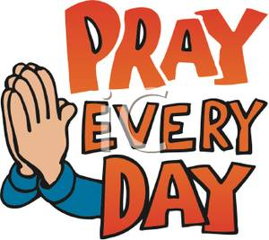
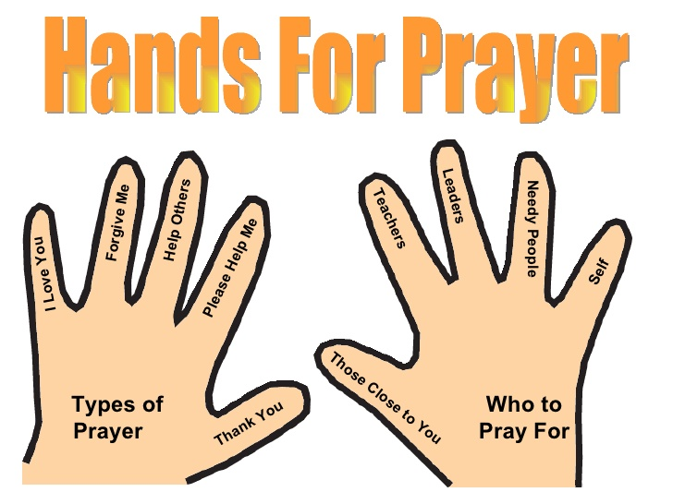

Sunday 17th May – Noah
Read Genesis chapter 6, verses 9 – end, Genesis chapters 7-9, stop at verse 17
Phew! There was a lot to read today but what a great story! Our lockdown so far has lasted over 40 days. Noah was on the Ark for approximately 370 days. He was not able to go for a walk on dry land, he could not see his friends and all his food provisions had to be gathered before getting on the Ark. During this time Noah showed great faithfulness and patience. He knew God was in control.
God is still in control today. All He asks is that we trust Him. The Flood came to an end. This Lockdown will come to an end.
Make/paint/draw/collage a big rainbow. Write a rainbow prayer of thanks to God. Each line needs to follow the colours of the rainbow: red, orange, yellow, green, blue, purple.
Find out the names of the people who were on the Ark with Noah.
Praise God for his faithfulness to us and ask Him to help us to trust Him for the future.
https://www.bing.com/videos/search?q=noah+for+kids&&view=detail&mid=D9DFF08FCE5DC0422339D9DFF08FCE5DC0422339&&FORM=VRDGAR&ru=%2Fvideos%2Fsearch%3Fq%3Dnoah%2Bfor%2Bkids%26FORM%3DHDRSC3 ^{watch the story}
Sunday 24th May – Joseph
Read Genesis chapter 39, verse 19 to the end and chapters 40 and 41
Joseph was put into prison for something he had not done! How unfair! Not being able to have the freedom we used to have before lockdown might feel unfair but it is necessary to keep us safe. Our lockdown so far has lasted over 40 days. Joseph was in prison for approximately 2 years. While he was shown favour by the guard he still lacked the freedom to go outside for a walk and follow his normal routine. During this time Joseph placed his trust in God. He knew God was in control.
God is still in control today. We need to be patient and show love to those close to us as Joseph showed care to his fellow prisoners. Joseph’s time in prison came to an end. This Lockdown will come to an end.
Make this picture to remind you of God’s faithfulness.
Find out what happened to Joseph after he left prison.
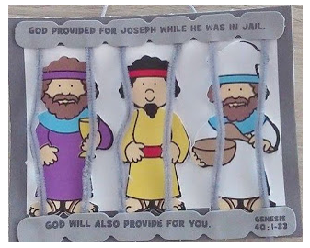
Pray for the people in your family and ask God to help you find ways to show that you care about them.
https://www.bing.com/videos/search?q=Joseph+in+Prison+Bible+Craft&ru=%2fvideos%2fsearch%3fq%3dJoseph%2bin%2bPrison%2bBible%2bCraft%26FORM%3dVDVVXX&view=detail&mid=4CBBD9C6822096E4696A4CBBD9C6822096E4696A&rvsmid=676AC7DBB21D61F22FD3676AC7DBB21D61F22FD3&FORM=VDQVAP watch the story
Sunday 31st May – Peter
Read Acts chapter 3 and chapter 4 verses 1- 3, Acts chapter 5, verses 12 to the end, Acts chapter 12, verses 1-19
Peter was put into prison for 3 separate times just for talking about God but Peter still remained faithful. Today there are people in other countries that are put in prison for their faith in God. We are so blessed in this country that we have the freedom to pray to God. It is difficult that we can’t meet with our friends from Church right now but we know that one day we will meet again. Peter knew God was in control and Peter was released from prison.
God is still in control today and we can look forward to being released from this lockdown in the near future.
Find out – What was special about Peter’s release from jail the final time?
Clue: read Acts chapter 12, verse 7
Try making this game:
https://www.biblefunforkids.com/2015/01/peter-freed-from-prison.html
Pray for other countries that are affected by this virus.
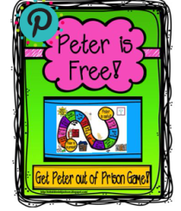
Some are beginning to return to work and school while other countries are still affected by the virus.
https://www.adventurebible.com/games/home/ games to play
Sunday 7th June – Paul and Silas
Read Acts chapter 16, verses 16 to the end
Paul and Silas were put into prison because God helped them to heal a servant girl. Not only were they in prison but they were held by metal chains. This would have been very uncomfortable but they still sang and praised God! Paul and Silas knew God was in control and God made it possible for them to be released from prison.
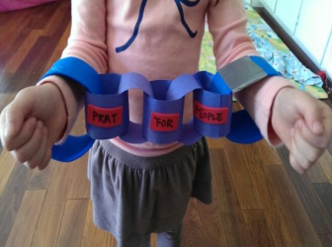
God is still in control today. Let’s still praise Him while we can look forward to being released from this lockdown.
Find out: What countries did Paul visit on his many travels?
Make a prayer paper chain or write a song praising God for His faithfulness during this time.
Pray for people as they recover from this virus that God would heal them and give wisdom to the scientists as they search for a new vaccine to fight the virus.
http://www.drawn2bcreative.com/ascension-jesus-craft/

Now you have found out about ‘Lockdown Hero’ from the Bible can you try to be a ‘Lockdown Hero’ today?
Stay Positive. Be Resilient. Show Love. Trust God.
You could design a poster of you as a superhero with the slogans shown in bold.

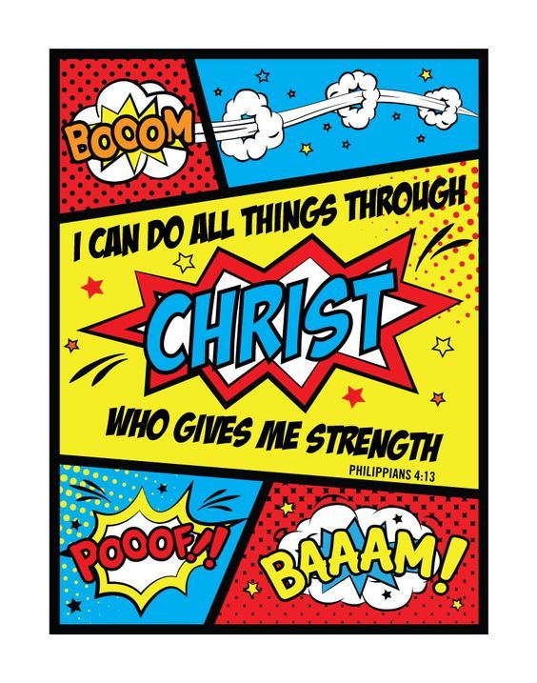
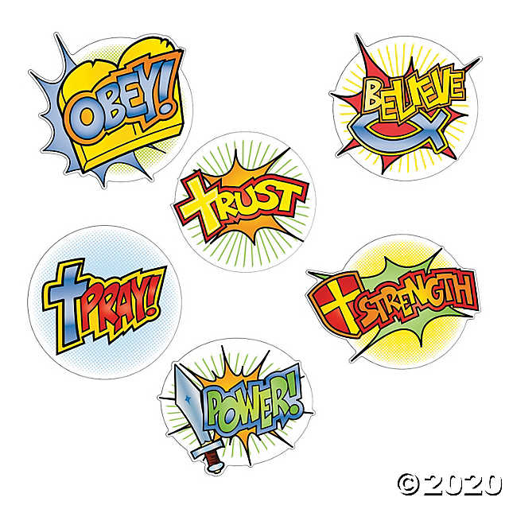

Ask your grown- ups to upload pictures of any activities you complete onto Facebook or Whatsapp so that your friends at church can enjoy what you have done. I’m still waiting to see these!!
It will encourage us all at this time and help to share smiles!
Keep safe, look after your families and I hope to see you soon
God bless, Love from Cathy, XX

